Conceptual ERD

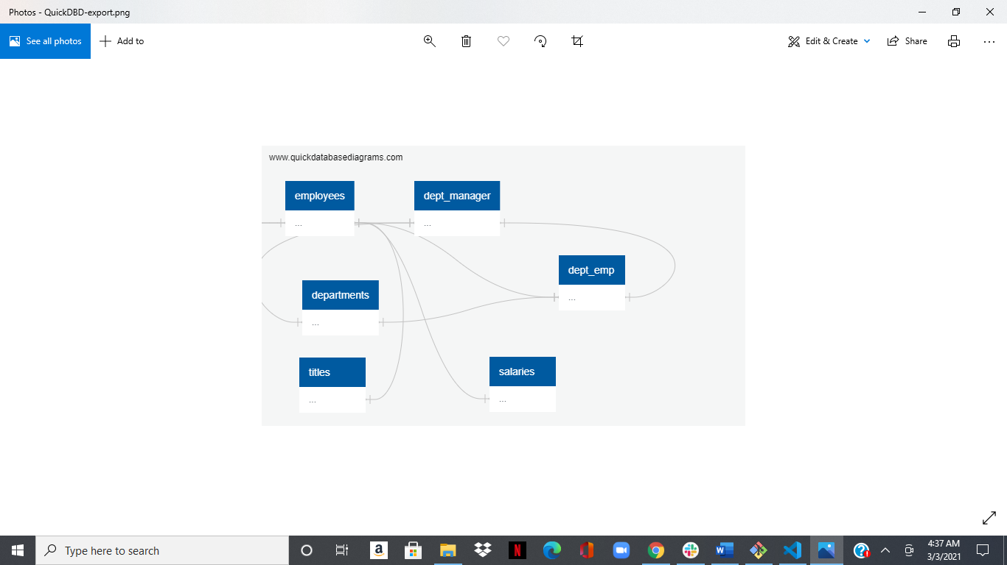

Logical ERD

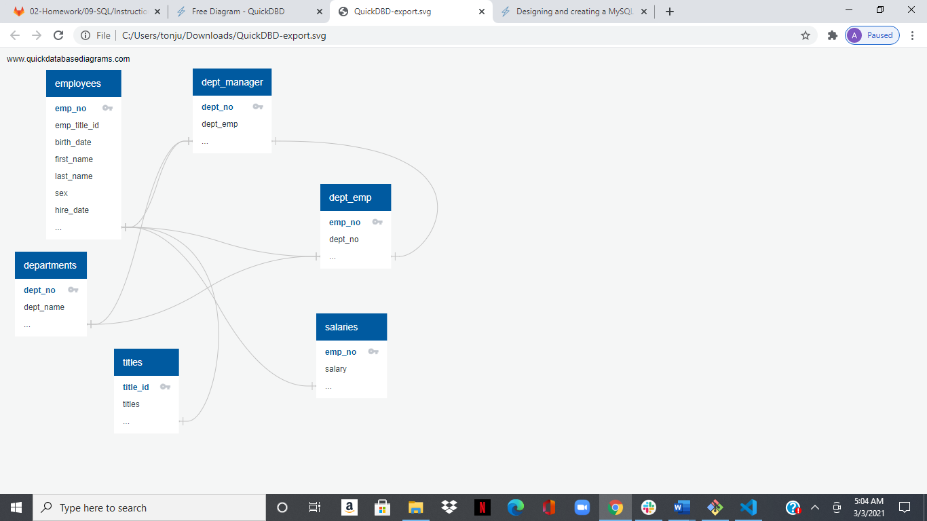

Physical ERD

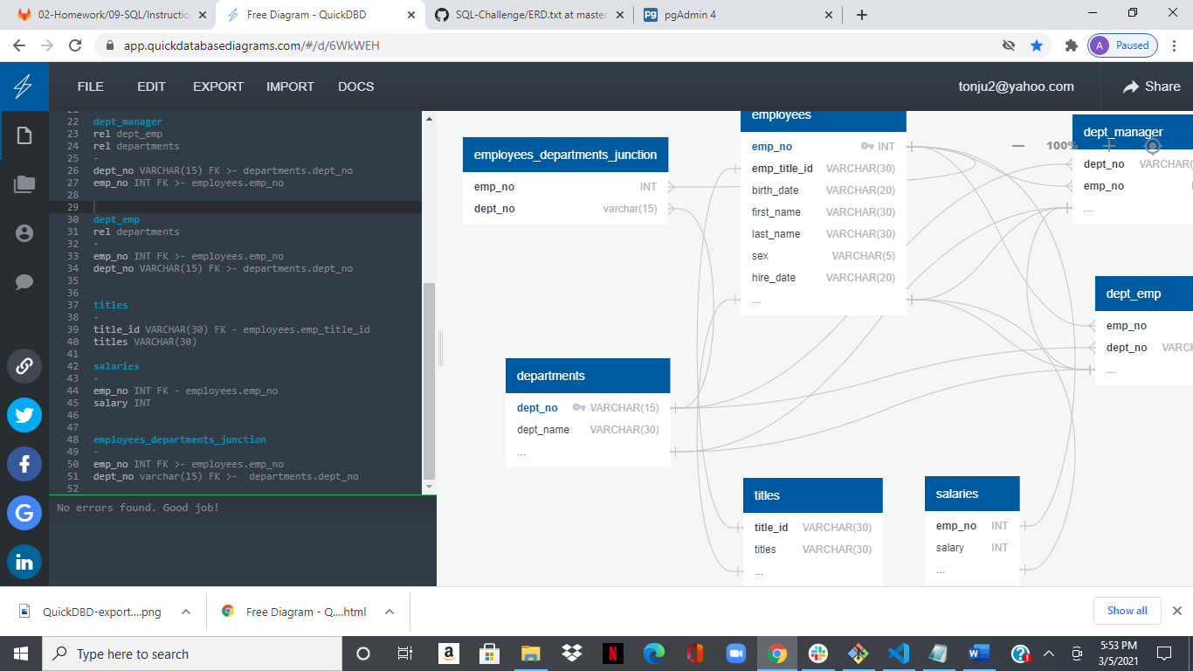

<https://app.quickdatabasediagrams.com/#/d/6WkWEH>